SMS Texting

These instructions assume that you have an active account in CloudCME. If you do not, please set up your account first. You can only record your attendance 60 minutes prior to the meeting, during the activity or 120 minutes after the meeting.

Step 1: Pair your mobile phone to your CloudCME account. Text your email address, entered in your Profile, to (888) 352-5547 to opt-in to the text message attendance program. You will receive a text message that your phone number has been updated. This is a one-time operation.

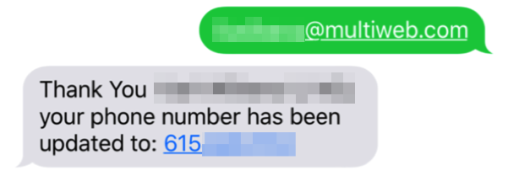

Step 2: To record your attendance to an activity, text the Activity ID or Activity Code that has been provided for your activity. You will receive a text message that verifies activity attendance has been recorded.

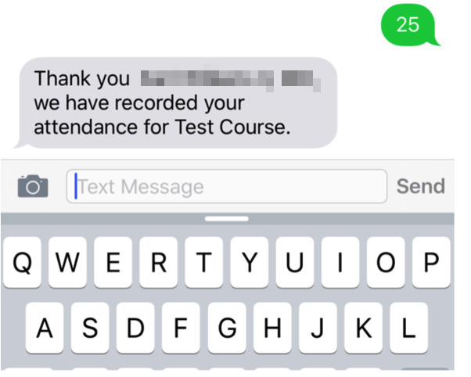

You will receive an incomplete profile text message if you try to text your attendance and have a missing degree and/or profession in your profile. Please complete the fields in your CloudCME profile before texting attendance.

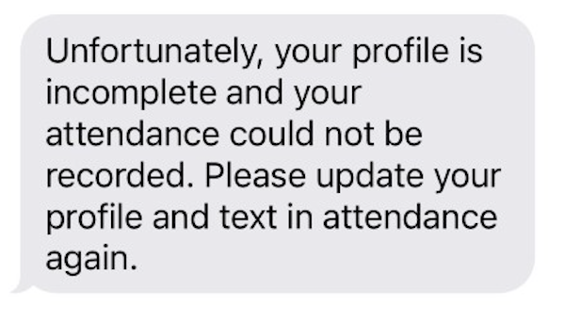

You can only record attendance once for an activity. If you try to record attendance an additional time, you will receive the following text message.

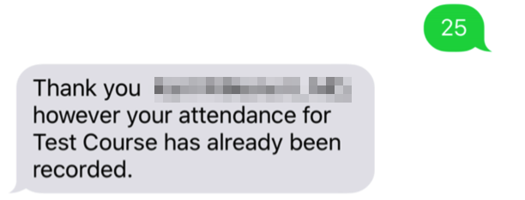

If you attempt to record your attendance for an activity to which you are not registered, you will receive the following text message.
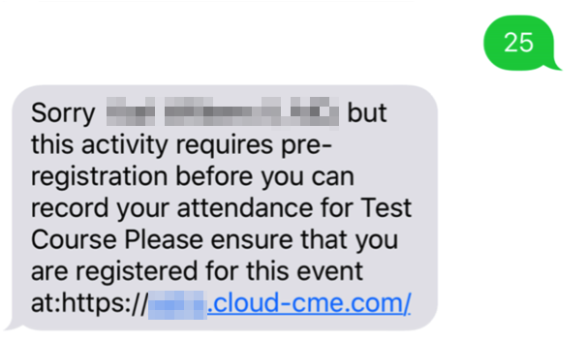

You must text an SMS text message not an iMessage, if using iOS.

